Enterprise Modernization



Engagement Manager and Architect Guide

9-Apr-15

Version 1.0 Final

Prepared by

**Microsoft**

Revision and Signoff Sheet

Change Record

|  |  |  |  |
| --- | --- | --- | --- |
| Date | Author | Version | Change Reference |
|  |  |  |  |
|  |  |  |  |

Table of Contents

1 Introduction 6

1.1 Purpose 6

1.2 Audience 6

1.3 Engagement Scenarios Overview 7

1.3.1 Discover 7

1.3.2 Target and Deploy 9

1.3.3 Migrate 14

1.4 Project Management and Oversight 15

1.5 Support 16

2 Engagement Scoping 17

2.1 Scoping 17

2.2 Cost Estimates and Projections 20

2.2.1 Determining Application Complexity for Per Application Unit Pricing Models 20

2.2.2 Engaging with Global Delivery 21

3 Pre-Engagement Guidance 22

3.1 Customer Preparation 22

3.1.1 Designating a Point of Contact 22

3.1.2 Obtaining Change Control Approvals 22

3.1.3 Environmental Prerequisites 23

3.2 Engagement Team Preparation 23

3.3 Enterprise Engagement Considerations 24

4 Staffing Guidance 25

4.1 Purpose 25

4.2 Staffing Guidance 26

4.2.1 Resource Requests 26

4.2.2 Staffing Model 26

4.3 Required Competences, Skills and Capabilities 27

4.3.1 Required Technical Competencies 27

4.3.2 Purpose 34

5 Engagement Guidance 35

5.1 Risk Assessment 35

5.2 Change Management 35

5.3 Release Management 35

5.4 Scheduling Constraints 35

5.5 Project Phases 36

5.5.1 Envision 36

5.5.2 Plan 37

5.5.3 Build 37

5.5.4 Stabilize 38

5.5.5 Deploy 38

5.6 Community Contribution and Engagement IP 38

1. Introduction

The end of support for Windows Server 2003 and Windows Server 2003 R2 is July 14, 2015. SQL Server 2005 resides on roughly 75% of the Windows Server 2003 instances as well. Customers need to assess how this affects the services they provide to their businesses.

The Microsoft approach to solving this problem for customers consists of a structured approach called Enterprise Modernization. This approach consists of discovering legacy servers and applications, providing a centralized application metadata information, deployment of target environments and the subsequent migration of Microsoft, 3rd Party or custom line of business applications.

For this initiative, the focus must be on the workload and not on just the upgrade of the operating system. In most cases, upgrading the operating system in-place to a 32-bit version of Windows Server 2008 is not a long term viable path and essentially mitigates the problem for a short period. Compatibility with a new operating system as well as performance is still a concern. Migrating an application from Windows Server 2003 requires analysis, compatibility testing, redevelopment in some cases, and migration of an interdependent and often outdated services and applications.

* 1. Purpose

The purpose of this Engagement Manager Guide is to provide concise yet important guidance on delivering Enterprise Modernization engagements utilizing both traditional MCS datacenter engagements as well as leveraging offshore resources in Global Delivery to accelerate application assessments and migrations. This guide provides key information on the project setup, resource requirements, project team composition as well as some key aspects of the engagement organization leveraging Microsoft Solution Framework. This engagement Guide is an integral part of Enterprise Modernization and should be used in conjunction with existing MCS offering documentation. While we recognize that every customer, resource and project is unique, we are publishing this document is order to support consistent, standardized and optimal delivery of Enterprise Modernization engagements.

In order to facilitate the application of the entire Enterprise Modernization solution, this Engagement Manager Guide presents a simple engagement framework, summarizing key challenges, prerequisites and aspects of the project. Detailed guidance and step-by-step processes can be found throughout the Enterprise Modernization for your customer.

* 1. Audience

This document was written to benefit the any IT professional assigned to envision, assess and plan, design and build target environments and migrate both Microsoft and 3rd party applications. In particular, document is aimed to Engagement Managers, Project Managers and IT Architects involved with Windows Server 2003 End of Support engagements. Although many of the steps in this document pertain especially to the Project Manager (PM) role, the provided summary can be used to initiate, support, and promote a more productive collaboration among the individual resources involved in Enterprise Modernization engagements.

* 1. Engagement Scenarios Overview

The scope of Enterprise Modernization is to provide four phases targeted at specific outcomes. These outcomes are meant to provide direct inputs into the subsequent phase. It is very important that the services and account teams plan a strategy which covers these phases for migration ***prior to presenting a plan*** to the customer. This will allow a presentation of a ***unified*** view of software and services (Premier and MCS) which are appropriate to modernize the customer.

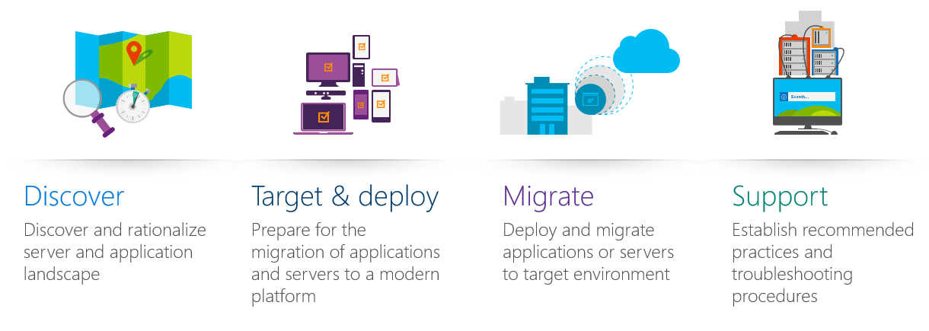

* + 1. Discover

The discover phase consists of 3 activities to identify a customer’s business goals, catalogue their server and application landscape and provides a business case to demonstrate the benefits of migrating and modernization your infrastructure.

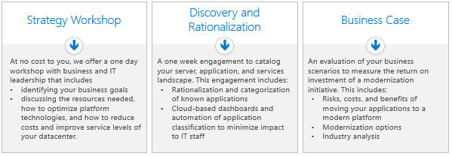

The outcome of the discovery phase should provide:

* Catalog all of a customer’s servers and applications and rationalize and categorize known applications
* Preliminary analysis of the catalog for modernization planning
* Identification of the customer business goals to develop a customized strategy for your migration
* Business case for proceeding with the modernization initiative

#### Strategy Workshop

The initial part of the discover phase is a one day ***pre-sales*** workshop with business and IT leadership. The Enterprise Modernization Strategy Workshop is a 1-day 1:1 customer session aimed at discussing the Industry trends driving the need for modernization, the benefits of modernization and the value it brings to enterprise customers, the customer strategy and drivers for modernization (Business and Technical) and the Microsoft approach to enterprise modernization. This workshop should help guide the customer to identify and prioritize key projects, and to mutually identify the next steps towards an application migration from Windows Server 2003 to a modern OS. This should typically be part of any modernization engagement to help a customer identify their business goals, discuss the resources needed for migration, how to optimize platform technologies, and how to reduce costs and improve service levels of your datacenter. The deliverables in this phase are a completed ***Enterprise Modernization Strategy Workshop Deck***. The Enterprise Modernization Strategy Workshop should be viewed as a ***required*** task with the customer in order to provide a plan of record of the business and technical decisions for the application migration strategy.

A Solution Architect or a Modern Datacenter COE Architect delivers the workshop itself, but the preparation work requires ATU involvement. The ATS or SE is expected to perform the initial TDM or BDM presentation to the customer in advance.

#### Discovery and Rationalization

The next part of the discover phase is one week engagement to catalog a customer server, application, and services landscape. Both Premier and MCS can deliver this service based on the way in which a customer wishes to pay for the engagement (Premier Hours or MCS). However, if a customer already knows their application and server environment, Discovery and Rationalization should be viewed as an ***optional*** task.

The deliverables for this engagement include:

* Rationalization and categorization of known applications
* CRM Cloud-based dashboard and automation of application classification to minimize impact to IT staff

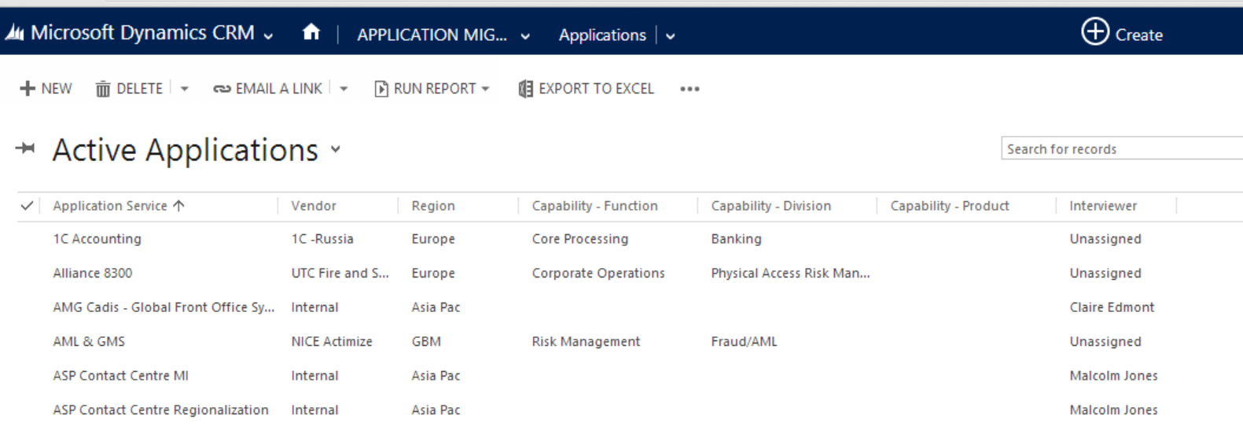

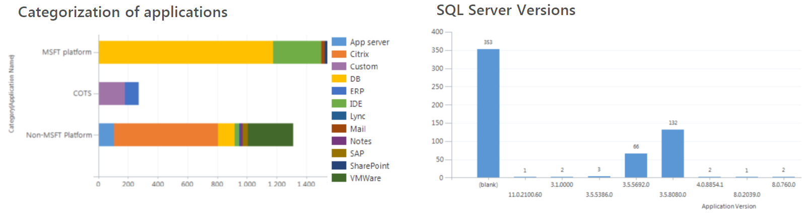

More information about Discovery and Rationalization can be viewed at <http://aka.ms/endr>

#### Business Case

Modernizing a customer’s infrastructure and applications is a major undertaking, especially if the enterprise is large, complex, multi-site, multilingual, or global. The customer may have such questions as: What return on investment (ROI) can I anticipate from this solution? How can I uncover and quantify indirect benefits? What should I budget for? How can I communicate this information to other stakeholders at my enterprise?

The **light** business case tool can estimate the typical ROI for modernizing applications and infrastructure based on a customer’s preferred target (On-Premise or Cloud) based on industry standards. The goal of the light business case is to provide a high level overview and potentially sell a customer a full business case that provides real numbers reflective to their business. The **full** business case is an industrialized service through ***global delivery*** that provides a quick turnaround (typically 3 weeks) to generate specific to your customer internal metrics.

Benefits of the **full** business case include:

* High-level overview and supporting details of where and how benefits will accrue from modernizing your applications and infrastructure.
* Projections of ROI, net present value, and other financial measures, with comparisons to industry benchmarks.

The **light** business case can be accessed [here](http://roi-eos.cloudapp.net/ENDR_Lite_BC_Tool/WelcomeScreen.aspx).

* + 1. Target and Deploy

The purpose of the target and deploy phase is to provide a target environment for migration. This is not necessarily deploying infrastructure. In some cases, it can be viewed as readiness and validation of a target environment. However, many customers may not have available capacity to be used for a migration environment. In addition, Azure can be leveraged as a dev/test environment to provide available capacity for migration testing as well as development environments. These services can span both MCS and Premier to provide environment readiness and deployment.

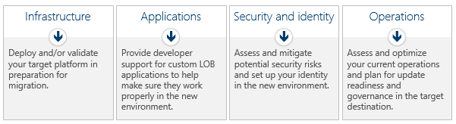

The goals of the Target and Deploy phase are to:

* Implement security and identity technologies to stay protected
* Determine target environments and prepare them for your applications
* Deploy Windows Server 2003 infrastructure, applications, and other Microsoft server applications

#### Infrastructure

The infrastructure target and deploy work stream consists of utilizing many of our existing MCS Datacenter services to architecture, design, and deployment of modern datacenter and cloud technologies. In addition, this may not require physical deployment of a new infrastructure but more of adding capacity whether it be on premise or cloud based. Validation and deployment of the available target environments is a ***pre-requisite*** for application migration.

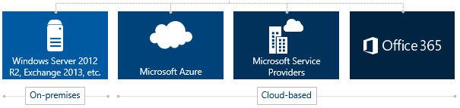

A starting point for many of these target and deploy services should be the Datacenter and Cloud Infrastructure management offering from MCS which includes both on-premise and cloud based deployment services. However, as noted below, there are many services from both MCS and Premier which can be utilized to accelerate the infrastructure deployment.

|  |  |
| --- | --- |
| **MCS Services**  *More info can be located* [*here*](https://microsoft.sharepoint.com/teams/ServicesPortfolio/SitePages/Offer.aspx?OID=415) | **Description** |
| ***Datacenter & Cloud Infrastructure and Management*** | This should be a starting point which includes both on-premise and cloud based deployment services. Includes **Architecture, design, and deployment** of modern datacenter and cloud technologies and products including security and identity. Includes **Management and Operations** of modern datacenter and cloud technologies and related workloads.   * Private Cloud / Hybrid Cloud / System Center * DevOps * Business Continuity / Disaster Recovery * Azure Dev/Test |
| ***Datacenter & Cloud Operations*** | **Assessment, planning, and optimization** of core datacenter and cloud operational processes such as cloud management, service request fulfillment, maintenance, performance, and reporting.   * Private and Hybrid Cloud Operations * Azure Operations * DevOps * Business Continuity / Disaster Recovery * Monitoring |

|  |  |
| --- | --- |
| **Premier Services**  *More Info can be located* [*here*](https://microsoft.sharepoint.com/teams/premierPortal/Pages/Home.aspx) | **Description** |
| ***Azure Fast Starts (7 Packages)*** | Designed to deploy Microsoft Azure solutions in select organizations in **60 hours or less** (for customers who meet deployment funds requirements) |
| ***RAP as a Service for Windows Azure Migrations*** | Understand the risks of upgrading your application and key dependencies before upgrade/migration activities |
| ***Building an Azure POC/Sandbox*** | Create your Sandbox environment (Fast Start) and configure/deploy a POC to familiarize with the environment |

#### Applications

Premier provides a service called Premier Support for Developers which can be leveraged during readiness or Target and Deploy. Premier Support for Developers (PSfD) is the most comprehensive Microsoft support offer that provides complete, end-to-end managed support across the full Microsoft developer platform—on-premises, hybrid, or in the cloud—helping developers throughout the development lifecycle.

|  |  |
| --- | --- |
| **Premier Services**  *More info can be located* [*here*](https://microsoft.sharepoint.com/teams/PremierPortal/Pages/PSfD.aspx) | **Description** |
| ***Premier Support for Developers*** | Premier Support for Developers gives customer access to a network of development experts including an assigned Application Developer Manager (ADM) who can help customer to navigate a full suite of services designed to fast-track customer solution, increase agility and help to be more cost efficient. This includes:   * Knowledge transfer across development technologies and methodology with ad-hoc readiness plan * ALM environment assessment with Testing Focus * Help building Azure POC/Sandbox |
| ***ALM Assessment with Testing Focus*** | Be prepared for the migration on ALM, TFS and Testing Techniques |
| ***Application Lifecycle Management Release Management*** | Assists in reduction of application cycle times and drives improvement in customer’s application release management process |

#### Security and Identity

Security and Identity readiness is paramount to any application transformation project. In many cases, leveraging security and identity assessments and services can uncover both issues that need to be addressed prior to migration such as tidying up Active Directory but also validating environment readiness for new security models. Both MCS and Premier provide services to facilitate readiness and validation.

|  |  |
| --- | --- |
| **MCS Services**  *More info can be located* [*here.*](https://microsoft.sharepoint.com/teams/ServicesPortfolio/SitePages/Offer.aspx?OID=615) | **Description** |
| ***Dynamic Identity Framework:***  ***Identity Assessments*** | The Identity Assessment is a **two week engagement** led by a Microsoft Identity expert, and is a collaborative engagement in which the architect works closely with the CIO of the organization and other core stakeholders to establish a holistic view of their identity. This ultimately leads to an actionable strategy for identity for the organization.   * **Inform (Day 1):** An Identity expert works closely with the CIO and stakeholders to provide a complete understanding of Microsoft’s view of identity and to set the expectation for the rest of the engagement. * **Assess (Week 1):** A series of breakout discussions with stakeholders and SME teams to establish an understanding of current infrastructure conditions, business requirements, key initiatives, and challenges. * **Analyze (Week 2):** Experts analyze the collected data and process it into actionable information with the assistance of customer executives and technical leaders in support of developing a holistic plan. * **Roadmap (Output):** The Microsoft account team will create and deliver a report that covers current state, the strategic objectives and desired end state outlined by the organization, and a prioritized roadmap that meets business needs and constraints.   More information and the Dynamic Identity Framework can be found [here.](https://microsoft.sharepoint.com/teams/ServicesPortfolio/SitePages/Offer.aspx?OID=615) |

|  |  |
| --- | --- |
| **Premier Services**  *More Info can be located* [*here*](https://microsoft.sharepoint.com/teams/premierPortal/Pages/Home.aspx) | **Description** |
| ***Active Directory Pre-Upgrade/ Migration Risk Management*** | Understand the risks of upgrading your Active Directory and increase your knowledge of the new functionality before upgrade/migration activities |
| ***Active Directory Security Risk Mitigation*** | Identify and reduce exposure to critical security risks in your Active Directory environment |
| ***Windows Server Platform Performance and Business Continuity Management*** | Implement a business continuity plan for your Active Directory infrastructure and review key performance counters that measure the health of your Windows Server platform |

* + 1. Migrate

Once you have a customer has their catalog of existing applications, identified migration targets and prepared the target environment, a customer is now ready to move forward with migration. This could be the ***starting point*** with many engagements as a customer may already know some of the required information as discussed before. There are 3 migration paths that a customer can select. The migration jumpstart as noted below is a quick way to get in quickly to migrate a bundled set of application based on complexity that will fit many BIF and CSA programs. The other migration types that a customer can select from are Per Server or Per Application. Per Server pricing is a fixed cost based on the caveats below. Per App pricing is also a fixed cost. However, it is based on application complexity. Refer to the Please refer to the chart below to understand the parameters with each.

|  |  |
| --- | --- |
| **Global Delivery Industrialized Service** | **Description** |
| ***Migration Jumpstart*** | Migration package options to get customers started quickly on the right path to a modern enterprise. These fixed scope engagements migrate custom Line of Business, Microsoft and/or third-party applications to target on-premise and off-premise environments.  **Sample Packages:** |
| ***Pay-as-you-go Migration –  Pay per app*** | With this fixed price model, your customer selects the Microsoft, 3rd party, and line of business apps they want to migrate that fit with their business goals, timelines, and budget. Use the unit pricing model or pricing calculator spreadsheet to calculate the cost and duration of their migration engagement. |
| ***Pay-as-you-go Migration –  Pay per server*** | With this model, customer selects the number of servers they want to migrate and pays a fixed price per server. To utilize this model, the customer’s scenario must meet the following requirements:   * Requires a minimum of 200 servers to migrate * Application count does not exceed 50% of server count (e.g. 100 applications and 200 servers) * Database count does not exceed 50% of server count (e.g. 500 databases and 1000 servers) * Must migrate at least 50 servers per month. * For on-premise migration only, does not migrate applications to Azure * Application modernization and code remediation not included. Includes a time-bound rationalization of applications moved to new platform. If application is not compatible, customer will need to utilize the per app migration offer. * Up to 50% of applications will include an upgrade |

* 1. Project Management and Oversight

New with Enterprise Modernization is the role of Project Management and Oversight. Proper governance is vital to the success of any project and its importance increases exponentially with a project’s complexity. Migrating to updated infrastructure can involve a range of different applications across heterogeneous infrastructure technologies. There are several reasons why modernization projects fail. Failure to overcome the challenges below could lead to complications and delays during your migration project.

* **Identify:** Identify and document project issues (current problems) and risks (potential events that impact the project)
* **Analyze & Prioritize:** Assess the impact and determine high priority risks and issues that will be actively managed
* **Plan & Schedule:** Decide how high-priority risks are to be managed and assign responsibility for risk management and issue resolution
* **Track & Report:** Monitor and report the status of risks and issues and communicate issue resolutions
* **Control:** Review the effectiveness of the risk and issue management actions

This role can be sold to the customer as a stand-alone offering to provide governance regardless of the delivery organization.

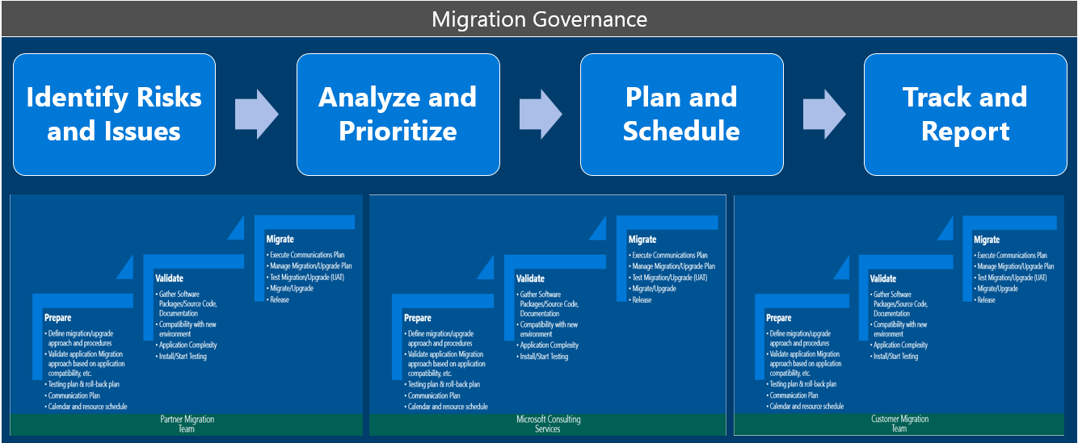

To properly scope this engagement, please email the AskNDPO team at [askNDPO@microsoft.com](mailto:askNDPO@microsoft.com)

* 1. Support

Premier offers a number of accelerate packages to provide post and pre migration services. As part of the planning exercise for each customer, you should determine which package should be presented to the customer based on the type of migration that is being planned. More information can be viewed through the [Premier Axis Portal](https://axis.microsoft.com/).

|  |  |
| --- | --- |
| Service | Description |
| **Active Directory Pre-Upgrade/ Migration Risk Management** | Identify and decrease the risks associated with migrating your Active Directory and increase your team's knowledge of the new functionalities |
| **Application Lifecycle Release Management** | Assists in reduction of application cycle times and drives improvement in customer’s application release management process |
| **Azure Fast Starts (7 Packages)** | Designed to deploy Microsoft Azure solutions in select organizations in 60 hours or less (for customers who meet deployment funds requirements) |
| **Active Directory Security Risk Mitigation** | Identify and reduce exposure to critical security risks in your Active Directory environment |
| **Windows Server Platform Stability Management** | Minimize risk before and/or after migration by implementing a recovery plan for your Active Directory infrastructure and reviewing key performance counters that measure the health of your Windows Server platform (WS 2008 to WS 2012 only) |
| **RAP as a Service for Windows Azure Migrations** | Understand the risks of upgrading your application and key dependencies before upgrade/migration activities |
| **ALM Assessment with Testing Focus** | Be prepared for the migration on ALM, TFS and Testing Techniques |
| **Building an Azure POC/Sandbox** | Create your Sandbox environment (Fast Start) and configure/deploy a POC to familiarize with the environment |

1. Engagement Scoping
   1. Scoping

A critical component for ensuring that the engagement will be successful is proper engagement scoping so that the correct project duration and workload can be established. The ideal way to accomplish this is to have a combination of main roles (architects and consultants) that will be performing the delivery assist the Engagement or Project Manager while scoping the initial engagement. This will help to build relationships between key delivery stakeholders and the customer, while reducing the time it takes to get the team knowledgeable enough for the engagement to start.

Enterprise Modernization scenarios are assessing the current infrastructure, defining a migration plan, designing and deploying the target platform and performing the migration to those target platforms. Actual scoping will be heavily influenced by complexity of the customer’s environment, availability of application owners, processes that will be anchored to the design and deployment of the target infrastructure and customer’s overall IT maturity. Due to the very nature of Enterprise Modernization engagements it is of utter importance to conduct a diligent and detailed scoping in order to prevent uncontrolled scope growth that could easily jeopardize projects profitability and completion. Many of the migration and target platforms below may not be needed based on the requirements of the customer for migration from Windows Server 2003. In order to scope the environment and timeline, there should be an [MCS](http://mcs)/[Global Delivery](https://microsoft.sharepoint.com/teams/globaldelivery/BusinessPriorities/Priority-Areas/Pages/Datacenter.aspx) architect to help with key topics for each phase:

|  |  |  |  |
| --- | --- | --- | --- |
| Enterprise Modernization Phase | Customer Needs | Service | Recommended Scoping Resources |
| **Discover** | Understanding Business and Technical drivers for application migration as well as mapping to a high level plan | **Strategy Workshop** – 1 Day | **MCS Architect (Enterprise, Datacenter CoE or Solutions Architect)** |
| Discovery of Windows Server 2003 applications and services with application rationalization (Microsoft, 3rd Party, Custom LOB) | **Enterprise Discovery and Rationalization** – 1 Week | **Premier (PFE) or MCS Architect/Consultant**  *\*Customer has choice to use Premier or MCS for delivery* |
| ROI/TCO of migration to a modern platform which can be used to sell to other stakeholders | **Business Case** – 3 Weeks | **Global Delivery / MCS Architect (Datacenter CoE or Solutions Architect)** |
| **Target and Deploy** | Readiness for a new platform or environment or assessment of current application/security infrastructure. | ***Premier Services***   * **Active Directory Pre-Upgrade**/ Migration Risk Management * **Application Lifecycle Release** Management * **Azure Fast Starts** (7 Packages) * **Active Directory Security Risk** Mitigation * **Windows Server Platform** Stability Management * **RAP as a Service** for Windows Azure Migrations * **ALM Assessment** with Testing Focus * **Building an Azure POC**/Sandbox   *\*Work with Premier TAM to determine timelines\** | **Technical Account Manager (TAM) or PFE** |
| ***MCS Services***  **Dynamic Identity Framework:**  Identity Assessments – 2 Weeks  *\*Refer to the DIF materials* [*here*](https://microsoft.sharepoint.com/teams/ServicesPortfolio/SitePages/Offer.aspx?OID=615) *to scope the appropriate engagement and timeline* | **MCS Solutions/Identity Architect** |
| Deployment of a new platform or environment | **Datacenter & Cloud Infrastructure and Management**  *\*Refer to DCIM Materials* [*here*](https://microsoft.sharepoint.com/teams/ServicesPortfolio/SitePages/Offer.aspx?OID=415) *to scope the appropriate engagement and timeline* | **MCS Architect (Datacenter CoE or Solutions Architect)** |
| **Migrate** | Proof of Concept or production migration of a small set of applications to on-premise or Azure | **Enterprise Modernization Migration Jumpstart** – 17 Weeks based on provided packages  *\*Must be scoped with* ***Global Delivery*** *in order to create the appropriate SOW. Custom creation of migration packages* ***require*** *Global Delivery Support as well.* | **MCS Solutions Architect (Datacenter CoE or Solutions Architect) / Global Delivery SSSP** |
| Migration of applications on a per application basis | **Pay-as-you-go per application** migration unit pricing model  *\*Must be scoped with* ***Global Delivery*** *in order to create the appropriate SOW.* | **MCS Solutions Architect (Datacenter CoE or Solutions Architect) / Global Delivery SSSP** |
| Migration of applications on a per server basis and customer can meet the assumptions provided in **Section 1.1.3** of this document for the pay-as-you-go per server pricing. | **Pay-as-you-go per server** migration unit pricing model  *\*Must be scoped with* ***Global Delivery*** *in order to create the appropriate SOW.* | **MCS Solutions Architect (Datacenter CoE or Solutions Architect)/ Global Delivery SSSP** |
| Multiple migration teams within the customer from many parties (Microsoft teams, customer migration teams and partner migration teams) | **Enterprise Modernization Project Management and Oversight -** TBD | **MCS Solutions Architect (Datacenter CoE or Solutions Architect)/ Global Delivery SSSP** |
| **Support** | On-going support after the migration is complete from risk assessments of the new infrastructure and application environment as well as business continuity. | ***Premier Services***   * **Application Lifecycle Release** Management * **Windows Server Platform** Stability Management * **RAP as a Service** for Windows Azure Migrations   *\*Work with Premier TAM to determine timelines\** | **Technical Account Manager (TAM) or PFE** |

It is highly recommended that an experienced solution architect assist in the pre-sales process to assess customer requirements and scope the specifics of the engagement. The Worldwide Datacenter COE and the Americas Office of the CTO have teams of datacenter solution architects who can assist with scoping and planning engagements.

* 1. Cost Estimates and Projections

Cost estimates and projections should be based on the guidance and pricing guidelines that are provided as part of the engagement materials of each offering. Due to varying complexity of the scenarios, as well as possible extensions of these scenarios (i.e. combining scenarios into an integrated project) detailed and precise scoping will be a major prerequisite for appropriate cost estimation and pricing. Please refer to the “Microsoft Applications and Services Statement of Work” and “Microsoft Applications and Services Work Breakdown Structure” document(s) within the Enterprise Modernization offering for detailed guidance. The Worldwide Datacenter COE (<https://microsoft.sharepoint.com/teams/dccoe/COEHub.htm>) and the Americas Office of the CTO have teams of datacenter solution architects who can assist with engagement scoping and planning.

* + 1. Determining Application Complexity for Per Application Unit Pricing Models

A key element of determining the unit price model to use for the application is understanding the complexity. To determine this, a questionnaire with a set of questions is available to obtain necessary the information to understand the complexity of the application called **Enterprise Application Migration Advanced - Diagnostics Hybrid Pre-engagement Questionnaire - Expedited**. This information should be provided to Global delivery to generate the appropriate statement of work. The process for this activity is illustrated below.

Figure 1 - SOW Creation Process for Migration Jumpstart or Per App Pricing

* + 1. Engaging with Global Delivery

In order to provide both the initial estimates for the Statement of Work for the Industrialized services mentioned previously (Business Case, Migration Jumpstart (including **per app** and **per server** pricing) it is necessary to engage with the offshore Global Delivery team. The subsequent sections outline the engagement model for both presales as well as migration delivery.

#### Global Delivery Presales

Global delivery has end to end presales process to support Enterprise modernization. Global delivery has Architects/ SME pools to support estimation process for Enterprise modernization to be included in both the initial statement of work for enterprise modernization as well as any subsequent statement of works for the migration of 3rd party application. Global delivery has industrialized the Enterprise Modernization offering and has unit price model.

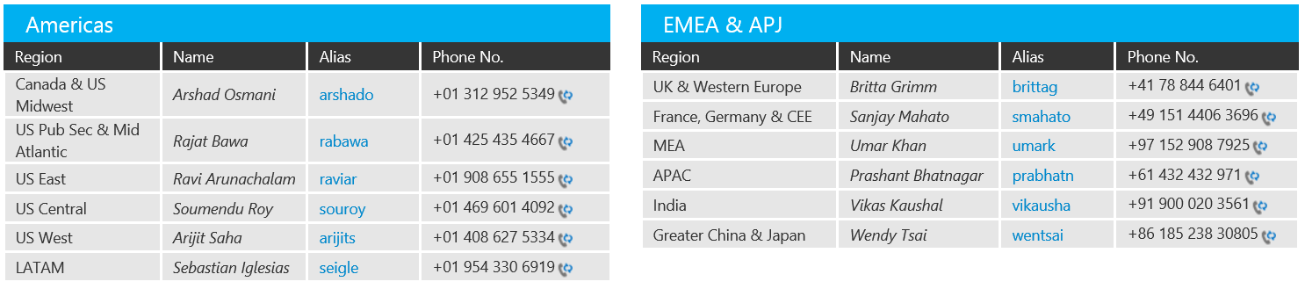

To initiate Presales process reach out to your regional GD SSSP. Please refer to this [link](https://microsoft.sharepoint.com/teams/globaldelivery/BusinessPriorities/Priority-Areas/Pages/Datacenter.aspx?eventId=1) for the most up to date GD contacts for your region.

#### Global Delivery Migration Support

Global delivery has end to end delivery process to meet all scenarios mentioned in Enterprise modernization. Global delivery has developed industrialized delivery model for various workloads involved in Enterprise Modernization. Also as continuous improvement process it includes newer workloads in industrialized service model year over year. For more details on industrialized workloads ([Click here](https://microsoft.sharepoint.com/teams/globaldelivery/BusinessPriorities/Priority-Areas/Pages/Datacenter.aspx?eventId=1)).

You can reach out to GD Delivery Manager for Enterprise Modernization Engagement Delivery

* + **Americas** - Sharanya Vemu ([sharanya.vemu@microsoft.com](mailto:sharanya.vemu@microsoft.com))
  + **International** - Nikhil Kulkarni ([nkulkarn@microsoft.com](mailto:nkulkarn@microsoft.com))

For detailed engagement model for each workloads – [Click here](mailto:https://microsoft.sharepoint.com/teams/globaldelivery/BusinessPriorities/Priority-Areas/Pages/Datacenter.aspx?eventId=1)

1. Pre-Engagement Guidance
   1. Customer Preparation

Customers can generally be divided into three broad groups: those who know their environments, those who do not know their environments, and those who believe they know their environments. Regardless of the customer’s profile, it is the role of engaged Architect/Consultant to gather enough accurate information about the customer’s business and migration requirements, IT environment and IT operational practices to plan, assess, build the target environment(s) and migrate the Microsoft applications which reside on Windows Server 2003 servers. Much of this information can be gathered from the output of the ***Enterprise Discovery and Rationalization*** offering which includes the customer application catalog as well as categorization. As noted prior, this data should be readily available as it is a prerequisite to Enterprise Modernization. Although the purpose of Enterprise Discovery and Rationalization will not fully define the specifics of every customer environment, an Architect/Consultant should be able to review the output that is provided and initiate the engagement with an accurate understanding of the related IT environment and requirements. This should be reviewed by the Architects/Consultants before the engagement begins (before the kick-off meeting).

* + 1. Designating a Point of Contact

It is imperative that the engagement delivery team and customer establish appropriate communication channels. Ideally this should be completed through a Single Point of Contact (SPoC) assigned at the customer side (usually Project Manager and IT Architect). SPoC should have a thorough understanding of the enterprise and its IT function and be able to provide adequate levels of customer engagement throughout the engagement.

Assigned SPoC should demonstrate following attributes and capabilities:

* Knowledge of the enterprise, with contacts in the various affected areas (infrastructure, system management, application management, service management, architecture function etc.) and the ability to work closely with these contacts to achieve objectives on a timely basis
* Authority to drive participation of reluctant business units.
* Project influence across multiple business groups and at the project sponsor level (business and IT management), allowing him/her adequate escalation capability and an ability to drive greater project visibility.

Sometimes the SPoC will be replaced with multiple points of contacts, each responsible for a specific segment of the enterprise. This situation is highly undesirable and will significantly increase overall engagement risk. Microsoft’s or partner’s project manager (or lead architect) will then assume a role of the “communication aggregating point”, effectively establishing and outsourced SPoC role. Such arrangement, while possible, will require strong commitment from the customers’ Business Decision Maker (BDM) audience and the risks should be reflected (accounted for) in the associated Statement of Work.

* + 1. Obtaining Change Control Approvals

If the customer’s operational procedures do not feature a rapid change control process, it is strongly advised that the engagement team initiates the change approval process as early as possible through submission of the following requests:

* Data center / servers installation. As the existing datacenter will be modified, or a brand new data center will be built and the building blocks need to be purchased and installed in the datacenter, this may require additional time, based on the customer’s hardware procurement and deployment process.
* Deployment, integration and release of the management system should be implemented in order to manage the whole lifecycle of the deployed private cloud. Implementing these new technologies in the production environment will likely require multiple change requests and approvals and will have to be anchored through formal Release and Deployment process.
* Migration and release of the target application should be implemented in order to manage the whole lifecycle of the migrated application. Migrating these applications in the production environment will likely require multiple change requests and approvals and will have to be anchored through formal Release and Deployment process.

Integration with external (legacy) systems and functions. If project includes significant integration with existing legacy systems the engagement should include an architectural design that clearly defines these specific requirements. As an example, requests should be created to approve and implement modification to the firewall structure in order to allow specific communication flow across security perimeters.

* + 1. Environmental Prerequisites

All servers to be deployed as a part of Enterprise Modernization scenarios require environmental changes (such as service accounts creation) to occur prior to installation. If extended lead time is expected due to change control processes, mandatory activities should be requested so that they will be ready at the time of installation. See the engagement materials for each target environment noted previously for exact target pre-requisite accounts, permissions and Active Directory changes to support the deployment of these environments.

* 1. Engagement Team Preparation

The measure of success for an engagement is not based entirely on the quality of the delivered components. Often, the customer’s perception plays a major role in whether a particular engagement is considered successful. Therefore, it is important to continuously monitor and manage this perception while delivering a high-quality engagement. In order to address these challenges:

* Provide each team member with access to the Enterprise Discovery and Rationalization output. This will be important as there will be multiple teams that leverage the data that has been gathered from this previous work stream.
* When the engagement’s team selection is final, initiate a team conference call to introduce the team members (local and offshore) and set the engagement expectations. At this time:
  + - Ensure that the consultants have access to the appropriate status report template and that they understand both the expected level of detail for the status reports and the proper process for risk reporting and problem escalation.
    - If necessary, discuss the current customer environment and acceptable expenses and provide written logistics for the customer facilities.
* Discuss and set the Conditions of Satisfaction (CoS) with the customer and refer to that list as often as necessary during the engagement delivery. Be aware that:
  + - If any customer decisions or engagement issues arise that affect these conditions, the customer must be notified and the list of engagement risks updated. The deliverable “Risk-Register (Template)” should serve as the central and updated repository of all recorded project risks.
    - Risk register is a critical component that must be maintained throughout the project. Issues, risks, and decisions need to be documented in detail and should include a description of each issue, the dates that pertain to the issue and the names of the involved resources. As the engagement progresses, this document will act as the core component if the CoS list is challenged.
    - You should provide an outlet for customer concerns through e-mail, phone, or personal contact. At key milestones, remind the customer of these outlets.
* Review the Day One and Week One activities with team members. To do so:
  + - Arrange meetings for the incoming consultants. Be sure to contact the proper resources to arrange for meeting rooms.
    - Realize that every consultant requires time to become accustomed to a customer environment. To bridge the experience gaps among various consultants, discuss the schedule and expected outcomes with each team member.
    - Understand that purpose of this review is to answer the inevitable question: where do I start?

Review the customer pre-engagement questionnaire with the team to identify gaps and create a list of follow-up questions and actions. Project Manager needs to pursue these gaps and questions while the team addresses technical challenges and assignments.

* 1. Enterprise Engagement Considerations

Typical engagement includes an Engagement or Project Manager, Solution or Infrastructure Architect, team of relevant delivery Subject Matter Experts (SMEs – consultants) and can also include other resources outside of standard solution delivery model (i.e. support engineers, service delivery managers etc.). Assigned resources follow a designated timeline and deploy the engagement through implementation (creation) of project deliverables. It is the responsibility of the Engagement and/or Project Manager to both track and drive these deliverables.

Enterprise Modernization will typically be delivered by a dedicated team of experts as outlined in the accompanying Work Breakdown Structure and Statement of Work, but it is important to understand and account for following keys challenges:

* In most consulting and system integration practices, the engaged resources are committed for several consecutive weeks to a single customer.
* Most resources are responsible for their own schedules. Therefore, it is possible for resources to schedule breaks between blocks of billable hours. However, such breaks are not guaranteed but remain at the discretion of the engaged consultants and their customers.
* In some situations, work may not be available or a consultant may be waiting for dependent efforts to be completed in another phase or track of the project. In these situations, consultant and the customer may decide to temporary disengage the consultant. Such arrangement has to be approved through joint project and/or engagement management function. If such agreement is reached, consultant is responsible to schedule an appropriate return date, as well as the conditions for that return.
* If an engagement is paused, but the return date and conditions cannot be identified and documented prior to the pause, or if the consultant does not agree to the pause, no guarantee will be made that the same consultant can return to that customer. The customer needs to understand and acknowledge this fact if a pause is discussed.

Maintaining continuity in enterprise engagements is important, so it is necessary to account for the dependencies at the onset of an engagement. The major dependencies are:

* Customer has plans in place for who will manage the final solution and how lifecycle management processes will be accomplished using the fabric management system.
* Customer has determined the Service Level Agreements (SLAs) that the solution will need to meet and will include the solution as the business critical component of its IT environment.
* Customer provisioned hardware and software for the project.
* Customer has plans to integrate existing IT services using third-party tools into any of three possible deployed solutions. Such plan should be reviewed against the contracted scope as described in Scope of Work and Vision and Scope documents.

Addressing these and other dependencies can take extended periods of time from the planned project schedule. It is, therefore, of outmost importance that all resources (consultants) engage in their roles with adequate materials, following planned schedule and working on explicitly defined deliverables. If a resource has to leave a particular thread of the engagement, a new resource needs to be able to take the deliverables that were written by the previously engaged consultant and proceed with minimal loss of productivity.

1. Staffing Guidance

This section outlines Enterprise Modernization project staffing, with particular focus on adequate competences and skills of delivery resources. This section will focus on the deployment of target environment deployment and will serve as the blueprint for engagement staffing.

* 1. Purpose

The purpose of this guidance for the offering is to:

* Define the competence requirements (both technical and non-technical) for the delivery resources who will be delivering the solution. Matching the required competence profile:
  + - Enables the consultants to integrate the required skills into their readiness and professional development plans.
    - Enables the Engagement and/or Project Manager to request the correct and assign adequate resources during engagement staffing.
    - Resource owners and Resource Managers of consulting/engineering practices/entities to identify the resources aligned with competence profile and thus plan capacity.
* Build the readiness plan in order to:
  + - Ensure adequate competence and capabilities of the delivery resources.
    - Provide the Resource owners and/or Resource managers consulting/engineering practices/entities with adequate insight regarding readiness planning and competence development investments.

Provide Engagement Managers and/or Project Manager with guidance on how to qualify the resources that they need for delivering Enterprise Modernization engagements.

* 1. Staffing Guidance

This section describes the engagement characteristics that affect resource requests. It also describes the roles and responsibilities of the delivery resources. Individual follow-up scenario staffing guidance will be provided in the accompanying scenario offering materials and will not be covered in this document.

* + 1. Resource Requests

After an engagement has been confirmed with the customer or partner through a signed work order, resource request must be submitted to the relevant Resource Manager. The Resource Manager will provide the delivery team (Architects, Consultants, vendor consultants) to fulfill the engagement need.

All resource requests should be submitted through standard resource request platform – <http://rpm>.

* + 1. Staffing Model

A customer representative and Microsoft resource must be in close contact throughout the engagement to ensure that the customer’s needs are being met and that the project is progressing as scheduled. Ideally, a team of experienced Microsoft resources will deliver Enterprise Modernization. Depending on the experience and capability of engaged resources Microsoft could provide additional (senior) resources or quality review capability to secure quality of the deliverables and successful project completion.

Project management activities for Enterprise Modernization may require a dedicated PM role. While many MCS resources possess significant project management experience, the massive scope of the engagement can surpass the capacity of an onsite MCS Architect/Consultant.

* 1. Required Competences, Skills and Capabilities

To ensure a project’s success, both technical and non-technical skills are required to address the different items of an engagement. Assigned resource must be capable of addressing all architectural and technical aspects of the project while leveraging their non-technical skills to secure high customer satisfaction and successful project completion. In addition, all resources should have soft skills to facilitate the project’s success.

* + 1. Required Technical Competencies

The following technology competences and capabilities are required to successfully deliver Datacenter Infrastructure and Management engagement include:

|  |  |  |  |
| --- | --- | --- | --- |
| Enterprise Modernization Phase | Activities | Service | Recommended Resources |
| **Discover** | Understanding Business and Technical drivers for application migration as well as mapping to a high level plan | **Strategy Workshop** | **One of the following:**   * Enterprise Architect * Datacenter CoE * Solutions Architect with business acumen |
| Discovery of Windows Server 2003 applications and services with application rationalization (Microsoft, 3rd Party, Custom LOB) | **Enterprise Discovery and Rationalization** | **Datacenter Architect/Consultant or PFE** |
| ROI/TCO of migration to a modern platform which can be used to sell to other stakeholders | **Business Case** | **Global Delivery** |
| **Target and Deploy** | Readiness for a new platform or environment or assessment of current application/security infrastructure. | ***Premier Services***   * **Active Directory Pre-Upgrade**/ Migration Risk Management * **Application Lifecycle Release** Management * **Azure Fast Starts** (7 Packages) * **Active Directory Security Risk** Mitigation * **Windows Server Platform** Stability Management * **RAP as a Service** for Windows Azure Migrations * **ALM Assessment** with Testing Focus * **Building an Azure POC**/Sandbox | **PFE** |
| ***MCS Services***  **Dynamic Identity Framework:**  Identity Assessments | **Identity Architect** |
| Deployment of the Hyper-V role, and other related roles on Windows Server 2012 R2   * Deployment of the following System Center 2012 R2 components: * Virtual Machine Manager (VMM) * Operations Manager (OM) * Service Manager (SM) * App Controller * Orchestrator | **Datacenter & Cloud Infrastructure and Management** | **Datacenter Architect /Consultant** |
| **Migrate** | Proof of Concept or production migration of a small set of applications to on-premise or Azure | **Enterprise Modernization Migration Jumpstart** – 17 Weeks based on provided packages | * **Architect/Consultant** for Scoping * **Global Delivery** for Delivery |
| Migration of applications on a per application basis | **Pay-as-you-go per application** migration unit pricing model | * **Architect/Consultant** for Scoping * **Global Delivery** for Delivery |
| Migration of applications on a per server basis and customer can meet the assumptions provided in **Section 1.1.3** of this document for the pay-as-you-go per server pricing. | **Pay-as-you-go per server** migration unit pricing model | * **Architect/Consultant** for Scoping * **Global Delivery** for Delivery |
| Project management and governance for multiple migration teams within the customer (Microsoft teams, customer migration teams and partner migration teams) that align to business and technical stakeholders. | **Enterprise Modernization Project Management and Oversight** | * **Engagement Manager**   + Customer Relationship   + Project Financials * **Project Manager**   + Schedule   + Communications Plan * **Enterprise Architect**   + Business Justification   + Return on Investment * **Lead Architect**   + Technical Leadership   + Approach   + Tooling * **Business Analyst(s)**   + Business Systems   + Application Owner Interviews * **Onsite Coordinator(s)**   + Discovery   + Factory Inflow/Outflow   + Factory Reporting |
| **Support** | On-going support after the migration is complete from risk assessments of the new infrastructure and application environment as well as business continuity. | ***Premier Services***   * **Application Lifecycle Release** Management * **Windows Server Platform** Stability Management * **RAP as a Service** for Windows Azure Migrations   *\*Work with Premier TAM to determine timelines\** | **Premier Field Engineer (PFE)** |

|  |  |  |
| --- | --- | --- |
| Microsoft Applications and Services | Activities | Recommended Resources |
| Active Directory 2012 Design and Deployment | Create a unified Active Directory structure, including integration with Microsoft Online Services if required, intended to become customer’s principal, worldwide user authentication directory. | * MCS Architect/Consultant (Identity/Security) |
| Exchange Server 2013 On-Premises Deployment | * Design, build, and stabilize an Exchange 2013 infrastructure * Enable coexistence with supported legacy versions of Exchange * Deploy production Exchange 2013 infrastructure to support a limited production pilot | * MCS Architect/Consultant (Exchange/Messaging) |
| Lync Server 2013 On-Premises Deployment | * Conduct a Network Assessment. * Develop the Technical detail design for the Lync 2013 infrastructure for the production environment. * Define Lync requirements for integrated systems and interfaces. * Deployment of the production Lync 2013 Infrastructure | * MCS Architect/Consultant (Lync) |
| SharePoint 2013 On-Premises Deployment | * Organizational Design * Active Directory Integration * SharePoint Server Design * Storage Design * High Availability * SharePoint 2013 PLA Farm | * MCS Architect/Consultant (SharePoint) |
| SQL Server On-Premises 2012 Deployment | * Identify upgrade requirements for Customer application server, disk, and databases. * Identify the databases supported and application connection requirements. * Establish the pre-migration Customer application performance baseline. * Upgrade Customer application from SQL Server 2005 or SQL Server 2008 to SQL Server 2012 on an existing or new hardware platform. | * MCS Architect/Consultant (Database) |
| Microsoft Dynamics CRM 2013 On-Premises Deployment | * Design and Deployment of Microsoft Dynamics 2013 | * MCS Architect/Consultant (Dynamics) |
| Microsoft Dynamics AX 2012 R2 On-Premises Deployment | * Design and Deployment of Microsoft Dynamics AX 2012 R2 On-Premises | * MCS Architect/Consultant (Dynamics) |
| Windows Server 2003 Infrastructure Roles (File Server) | * Assistance in envisioning, planning, deployment and migration of files and file shares on Windows Server 2003/2003 R2 Servers. | * Global Delivery Consultant * Local MCS Consultant (Infrastructure) |
| Windows Server 2003 Infrastructure Roles (Print Server) | * Design new set of Print Servers, including Hardware sizing, storage requirements, server settings * Assist with the Installation of the Windows Server 2012 R2 Print Server(s) in the production site * Migrate all print queues and their permissions | * Global Delivery Consultant * Local MCS Consultant (Infrastructure) |
| Windows Server 2003 Infrastructure Roles (DHCP Server) | * Assistance with design of DHCP Servers, including hardware sizing, storage requirements, server settings, IP address scope and exclusion, DNS and default gateway configuration * Conduct a trial migration against one of the Customer Name’s existing DHCP Server instance to the new DHCP Server. | * Global Delivery Consultant * Local MCS Consultant (Infrastructure) |
| Windows Server 2003 Infrastructure Roles (DNS Server) | * Assistance with the design of DNS Servers, including hardware sizing, storage requirements, server settings * Conduct system tests to validate the trial migration using system test plan. | * Global Delivery Consultant * Local MCS Consultant (Infrastructure/Security) |
| Windows Server 2003 Infrastructure Roles (PKI Server) | * Support planning for a Root CA * Support planning for a new CA for machine certificates * Support planning for the migration of certificates | * Global Delivery Consultant * Local MCS Consultant (Security) |
| Windows Server 2003 Infrastructure Roles (RMS Server) | * Assessment of your network topology, Active Directory service environment, messaging and portal current Active Directory Rights Management Services (AD RMS) integration * New AD RMS solution architecture * Integration with Microsoft Exchange Server email services either on-premises or online * AD RMS client implementation | * Global Delivery Consultant * Local MCS Consultant (Exchange/Security) |
| Windows Server 2003 Infrastructure Roles (Terminal Server) | * Assess the existing infrastructure and determine complete requirements. * Design new Remote Desktop Service (RDS) using a Windows Server 2012 R2 infrastructure: * Design and determine placement of RDS role services (RDS Licensing, Remote Desktop Server, RDS Web Server, RDS Gateway and RDS Session Broker) * Determine hardware requirements for the RDS infrastructure and Remote FX features * Build, configure, and deploy RDS Windows Server 2012 R2 servers and configure RemoteFX feature | * Global Delivery Consultant * Local MCS Consultant (Infrastructure) |
| Active Directory Migration | * Understanding of the existing Active Directory Environment and the different roles deployed and finalize the Side-By-Side migration path described below during Envision Phase. * Windows Server 2003/2003 R2 Active Directory to Windows Server 2012 R2. * Microsoft will perform a Side-by-Side migration of existing Active Directory environment to Windows Server 2012 R2. | * Global Delivery Consultant * Local MCS Consultant (Infrastructure/Security) |
| SQL Server Migration | * Migration and upgrade of SQL Server 2000 2005/2008 instances and databases to SQL Server 2008/2012/2014 for the following use cases: * AS-IS Migration of SQL 2005 DTS/SSIS packages to SQL 2008 R2 SSIS packages * Creation of deployment packages for the migrated databases/SSIS packages * Unit testing the migrated databases. | * Global Delivery Consultant * Local MCS Consultant (Database) |
| Office 365 Migration | * Migration of Exchange Server 2003/2007 mailboxes and SharePoint Server 2007 content to Office 365 | * Global Delivery Consultant * Local MCS Consultant (Exchange) |
| Exchange Server Migration | * Design of the coexistence strategy between source and the target Exchange 2013 environments. * Deploy migration toolkit in the production environment * Migrate a sample production pilot of mailboxes from Source to target for customer locations. | * Global Delivery Consultant * Local MCS Consultant (Exchange) |
| SharePoint Server content Migration | * Upgrade of data encompassing MySites and site collections from SharePoint 200(X) to SharePoint 2013 [On-Premises/O365 D/O365 MT] | * Global Delivery Consultant * Local MCS Consultant (SharePoint) |
| Microsoft Dynamics CRM 4.0 Migration | * Migration from Dynamics CRM 4.0 to CRM 2013 | * Global Delivery Consultant * Local MCS Consultant (Dynamics) |
| Microsoft Dynamics AX 2009 Migration | * Migration from Dynamics AX 2009 to Dynamics AX 2012 R2 | * Global Delivery Consultant * Local MCS Consultant (Dynamics) |
| Configuration Manager Migration | * Migration from Configuration Manager 2007 to System Center 2012 R2 Configuration Manager | * Global Delivery Consultant * Local MCS Consultant (Client/Infrastructure) |
| Operations Manager Migration | * Migration from MOM2005/SCOM2007 to System Center 2012 R2 Operations Manager | * Global Delivery Consultant * Local MCS Consultant (Operations/Infrastructure) |

Additional detailed guidance on technical competencies is included in the associated Consulting Delivery Guide for each Target Application or Platform.

* + 1. Purpose

Enterprise Modernization will require substantial soft-skills capabilities of delivery resources due to “high-touch” nature of the projects and an integral requirement to work across multiple groups and functions within customer’s ecosystem:

* Strong communication and presentation skills
* Ability to work in ad-hoc teams against floating goals
* Ability to quickly learn new skills and apply them in running engagement
* Ability to adapt communication and working style to accommodate various customer cultures
* Assertiveness and an ability to clearly communicate and support project goals and deliverables
* Advanced problem solving ability
* Task prioritization and strong time management capability

All other key non-technical capabilities are defined in the Microsoft’s internal consulting/architect Career Stage Profiles – <http://hrweb>.

1. Engagement Guidance
   1. Risk Assessment

Risk is an integral part of any IT project. The best way to deal with engagement risks is to identify them in a risk register as soon as they become apparent and highlight them in weekly status reports. Establish which customer employees have the authority to address the following question: “What is an acceptable risk for the organization?” After the level of risk has been agreed upon, mitigation strategies can be established.

* 1. Change Management

During the course of a large project, changes in scope will inevitably occur as overlooked items become apparent. The changes must be prioritized so that they do not delay the critical path but conclude in a timely fashion, without affecting the originally planned work. A change request must be submitted for each required change. The request needs to include both the cost and the proposed resources’ requirements and should be reflected through subsequent update of the project’s Statement of Work document. Also, note that every unforeseen change brings additional risk.

* 1. Release Management

Every document that is presented to the customer needs to include release information. Ideally, the customer will sign off all the documents that include decision information before any follow-on activity (such as configuration) begins.

Note that many customers also run an internal release and deployment process and that your project might have to integrate into standardized procedures and customer’s process model. This requirement has to be recognized during project’s scoping and included into cost estimation, risk register, Statement of Work and all other relevant pre-engagement documents. While having a release and deployment process in place clearly signals increased customer maturity it does introduce additional level of complexity and risk into the project.

* 1. Scheduling Constraints

The primary scheduling constraint for Enterprise Modernization is availability the adequate delivery resources. Typically, capabilities to work with multiple product stacks and in highly heterogeneous environment are fairly limited in any professional services organization. Combined with an intrinsic complexity of the advanced IT management functions, processes and capabilities it can present a major challenge for successful completion of any project.

* 1. Project Phases

It is strongly recommended Enterprise Modernization projects adhere to Microsoft Solution Framework process model in order to leverage its maturity, standardization and repeatability.

|  |  |  |  |
| --- | --- | --- | --- |
| Solution phase | MSF process model phase | Enterprise Modernization Phase | Delivery team focus |
| Plan | Envisioning | *Assessment Phase* | Through workshops with the customer, team defines the vision and scope of the project based on the business needs. When the engagement is agreed, the delivery organization defines the project and creates the approved Vision and Scope and Scope of Work. |
| Planning | *Modernization Phase* | Again through workshops with the customer, team develops conceptual, logical, and physical designs, and creates the architecture and operation guides. It also develops the project plan, addressing development, testing, communication, and other tasks, and it creates and delivers the master project schedule |
| Build | Developing | *Target Platform Deployment* | Team builds and tests the solution. |
| Stabilizing | *Target Platform Deployment* | Team completes the solution testing activities, and performs pilot reviews. |
| Deploy | Deploying | *Migration* | Team works with the customer to migrate the application(s) and ensures that the scenario is stable and usable. Responsibility then shifts from the project team to the customer’s operations and support organization. |

More details on the above-mentioned phases are provided in following few sections.

* + 1. Envision

The Envision phase, which initiates the engagement, is an important phase for verifying that the delivery team and customer expectations for the project are aligned. Typically, most of the components of the Envision phase will have been mentioned during the pre-sales phase of the engagement or during Enterprise Discovery and Rationalization, but it is still important to review all the components during the Envision phase to confirm that nothing has changed and to document those components in the Vision and Scope and Statement of Work documents.

The components of the Envision phase include:

* Determine the business requirements. Identify the business drivers for deployment of the migration priorities of the Windows Server 2003 applications and services. Typical business requirements include:
  + - Ability to provide improved SLA to the business and improve availability of the existing IT services or applications
    - Improve agility of IT services and functions toward business users
    - Reduce overall business risk and fulfill compliance/regulatory requirements
    - Provide business with single point of access to IT function, driving end-user satisfaction and business value
    - Consolidate application and infrastructure management capabilities reducing Total Cost of Ownership for of key infrastructure and application platforms
    - Determining the technical requirements. Identify the technical aspects of the solution that will be required to meet the business requirements. Technical requirements may include:
    - Availability, resilience, business continuity, fast recovery capabilities
    - Administrative boundaries
    - Security level
* Assessment of the current application environment for Windows Server 2003. The areas to focus on include:
  + - The current architecture of Windows Server 2003 IT services in the overall IT ecosystem
    - Infrastructure architecture and network composition
    - Key Windows Server 2003 platforms and systems currently in production.
* Determining the vision and scope of the project. This step consists of confirming what was already accomplished during the pre-sales efforts with the customer, and creating the Vision and Scope document of the project.
  + 1. Plan

The Plan phase goes deeper into details of the solution, discussing and creating a detailed migration plan as well as design specifications of the technology and operational aspects of the selected scenario.

This phase also provides detailed plans related to the subsequent phases.

* + 1. Build

The first step of the Build phase is to build and test the target platform(s). This activity is supported by a test platform, built according to deliverables provided by previous phases.

The phase also provides operational procedures related to functional implementation of the solution within production environment and its integration into overall IT ecosystem. It also provides a deployment planning guide and a deployment project plan, key components of the Stabilize and Deploy phases.

* + 1. Stabilize

The Stabilize phase includes conducting a pilot deployment of the target platform(s) before the full deployment can safely occur. The scope of the pilot deployment will be described during the engagement. It should include appropriate environment size (i.e. scaled to the scope identified in earlier phases) to provide valuable and relevant information to the deployment team. Pilot production is a key step of the project’s schedule since it collects and reviews information necessary to deliver last revision of documentation before deployment.

* + 1. Deploy

The Deploy phase can occur very quickly, depending on how the services are deployed. Most deployments should be able to be completed in no more than several days, assuming that previous phases were implemented with due diligence and thorough testing. Post-deployment activities, however, can continue through extended period (depending on the project schedule).

The migration activities as part of the deploy phase depend on the overall needs of the customer and the support required.

* 1. Community Contribution and Engagement IP

The inherent complexity and emerging characteristic of Enterprise Modernization will likely result in the creation of new IP – document, guidelines, tools and best practices. All of these are crucial to the mission of the offering team and Microsoft Services since they will allow us to improve and further develop our offerings and capabilities. The Enterprise Modernization components are “living documents” which will be updated as new information is discovered, corrections are made, feature areas have had customer exposure and field deployment experience is gained.

If you have tools that you depend on for the successful delivery of an engagement, or if you felt it necessary to augment the material in this solution, the Datacenter and Cloud Infrastructure team would welcome your feedback and assistance.

To discuss how you can contribute to the offering, please contact Fred Harmon: [fredhar@microsoft.com](mailto:fredhar@microsoft.com)